For this task, to predict the sales in four different product types while assessing the effects service and customer reviews have on sales, I ran our data through four different models: a linear regression model, a support vector machine model, a random forest model, and an extreme gradient boosting model.

After cleansing the test data, training the model, and running the test set through it, I determined the best model to be the random forest model. This one had the best RMSE based on the test data set run through each of the models.

Model | R-squared | RMSE
Linear Regression (lm) | .6771022 | 1073.045
Random Forest (rf) | .6186223 | 966.592
Support Vector Machine (svm) | .70489 | 1143.277
Extreme Gradient Boosting (xgb) | .48589 | 2092.03

For the Random Forest model we can be approximately 62% confident in our answers based on the R2 value.

Here are the predicted volumes for the four target product types: PC, Laptop, Netbook, SmartPhone.

Product Type | Predicted Sales Volume
Smartphones | 1291
PC | 656
Netbook | 1477
Laptop | 261

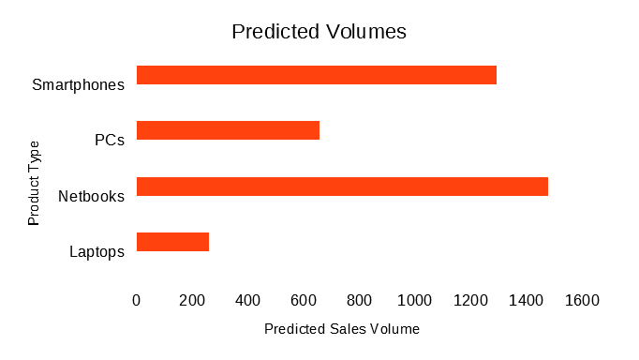
With respect to the affect of service and customer reviews on sales, below is a table demonstrating the correlation between each of the service and customer review types and sales volume. The higher the value the more highly correlated the two are. Note that 5 star reviews are extremely correlated to sales volume, and therefore indicates the higher the customer review the greater impact on positive sales volume. The same can be said of positive service reviews, in that positive service reviews are highly correlated with sales volume.

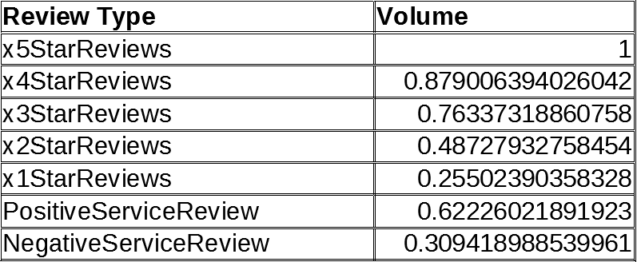

From this analysis, we learned that negative reviews definitely impact sales volume, but positive reviews are more impactful.

As far as business value, this was a very useful exercise. I can see how I can use this process to model product performance for my own company’s portfolio of products and services.

It was very straightforward to run from one model to the next, although I need to spend some time reviewing what each model does and ensure I understood the potential optimization values for each model.

I spent a lot of time understanding the potential cleansing functions in R. I also spent a fair amount of time studying the differences between regression and classification models and how these different models can be used to predict outcomes for each type of model – where the label is either continuous or categorical. This was the point of the reading on parametric versus non-parametric data sets. It became clearer after this exercise that scaling features prior to processing them is important when the features are continuous and of different scales from one another.

I have also realized I need to be really patient as I meticulously work through these problems following the outlined process and not skipping steps or refactoring the process. If I follow it, I seem to be able to make things work sufficiently. It is going to take more practice to make R more nature to program for me from memory, but in the meantime, there are a ton of resources online.

My recommendations to sales regarding the different types of reviews is two-fold:

1. Focus on the content of the most positive reviews to create your sales message.
2. Create a list of recommendations for service and product teams to focus on for next iterations of product based on customer feedback found in the more negative reviews where possible. This could be used to inform product strategy and service process improvements for those respective organizations.

